The Dodo

formerly known as ‘Didus Ineptus’ has been renamed ‘Raphus Cuculatus’

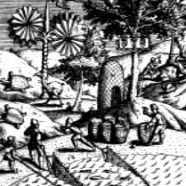
The Dodo formerly known as 'Didus Ineptus' has been renamed 'Raphus Cuculatus' The Dodo is the most famous extinct species in the history of Planet Earth. Its first contact with Europeans was in 1598, when a Dutch expedition headed by Admiral Jacob Cornelius van Neck landed on an island, thick with dense forests of bamboo and ebony, off the East coast of Africa. The island was named Mauritius by the adventurous and artistic Admiral – the first man to draw the extraordinary and unique flightless bird, now universally known as the Dodo (from the Dutch word 'dodoor' meaning sluggard). The demise of the Dodo has been attributed to hungry Dutch sailors en route to the Spice Islands of Indonesia. They would take a dinner break on the tropical island and consume the defenceless Dodo, but it was clearly an acquired taste as the sailors named it 'valghvogel'- meaning disgusting bird.
The island of Mauritius is only 10 million years old and until the arrival of European settlers, there were no island predators to threaten the easy-going existence of the Dodo, a bird that had evolved from the African fruit-eating pigeons of the genus ‘Treron’. This benign, predator free paradise had allowed the Dodo to evolve into a pedestrian bird with tiny wings unable to rise even a few inches off the ground. The Dodo was no match for the cunning, domestic pets of Europe and within less than a 100 years after the first landing of van Neck and his band of adventurers, the Dodo was extinct -- the last egg devoured, no doubt, by an overstuffed rat whose ancestors had emigrated from the sewers of Amsterdam with the original Dutch colonists.
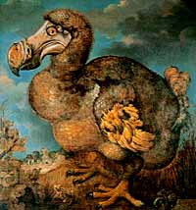
The popular image of fat and stupid creature comes from the celebrated painting of the Dodo by Jan Savery (1589–1654). On his visits to the Oxford University Museum, Lewis Carroll was inspired by this image and the only remaining Dodo skull and claw (both are still on display there), to create his own fictional version for ‘Alice's Adventures in Wonderland’:-
“When they had been running half an hour or so, the Dodo suddenly called out "The race is over”, and they all crowded round it, panting, and asking “But who has won?”'
That image of the weird, flightless, dim-witted Dodo is now being challenged by contemporary scientific research. Dr Andrew Kitchener has created two life-size reproductions of the Dodo – one is housed in the Royal Museum of Scotland in Edinburgh and the other is in the University Museum, Oxford. They are based on research using hundreds of actual Dodo skeletons and bones unearthed by naturalists in the Mare aux Songes swamp in South-east Mauritius. The new slimmer, streamline Dodo is very different from the fat, cuddly buffoon celebrated in the picture of Jan Savery. Dr Kitchener's research presents us with a lithe, active, smart Dodo superbly adapted to live and survive prosperously in the forests of its native Mauritius. The popular image of a fat, immobile, flightless dodo was drawn by de Savery and his contemporaries because the live specimens that they used as models had been shipped over to Europe on a diet of ships biscuits and weevils and then overstuffed by their over-zealous owners as they exhibited them to the general public. And in 1991 further credence was given to this new image of the Dodo, when a series of long-lost drawings by Harmanszoon dating from 1601 were discovered in the Hague after having been lost for over 150 years. These drawings confirm the thin streamline image first seen in van Neck's drawings of the Dodo from 1598.
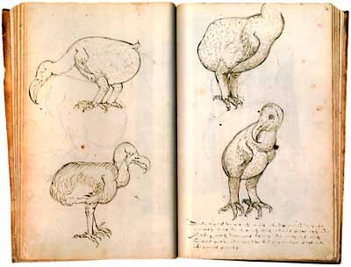
We will never know exactly what the Dodo looked like, but this enduring symbol of casual, careless extinction will continue to fascinate generations to come.

Acknowledgements: http://www.dodopad.com/dodofact/dodofact.htm

